UNIT 6 -

Incomplete unit. PRACTICE equivalence classes

Finish all the activities Do n-ary relations 6.4

Do equivalence relations Do functions 6.5

# Weak partial order

A relation R on a set A is called a *weak partial order* iff R is

* reflexive on A,
* antisymmetric, and
* transitive.

# Weak total order

A relation R on a set A is called a *weak partial order* iff R is

* reflexive on A,
* antisymmetric and transitive,
* and satisfies trichotomy

# Strict partial order

A relation R on a set A is called a strict partial order iff R is

* irreflexive,
* antisymmetric, and
* transitive.

# Strict total order

A relation R on a set A is called a strict partial order iff R is

* irreflexive,
* antisymmetric and transitive, and
* satisfies trichotomy.

# Strict total order

For a nonempty set A, a *partition of A* is a set S = {S1, S2, S3, …}. The members of S are subsets of A (each set Si is called a *part* of S) such that

1. for all i, Si =/ 0/ (that is, each *part* is nonempty),
2. for all i and j, if Si =/ Sj, then Si ∩ Sj = 0/ (that is, different parts have nothing in common), and
3. S1 ∪ S2 ∪ S3 ∪ … = A (that is, every element in A is in some *part* Si).

# Equivalence relation

A relation R on a set A is called an equivalence relation if R is

* reflexive on A,
* symmetric, and
* transitive.

# Types of orders

reflexive

irreflexive

Weak partial Order

Antisymmetric

trichotomy

Transitive

Strict total Order

Strict partial Order

Symmetric

trichotomy

Weak total Order

reflexive

Equivalence relation

R.S.T.

Equivalence classes/ Partitions

Equivalence relation

R.S.T.

# Partitions

* Equivalence relations create partitions.
* The reverse also applies, partitions also help identify Equivalence relations
* Learn the notation for these

e.g. [x] = {-4,-2,0,2,4} **and** [y] = {-6,-3,0,3,6}

therefore, S = {[x],[y]}, so [x] and [y] are equivalence classes of S

* Remember, equivalence classes have ***NO ELEMENTS IN COMMON***

So, [x] ∩ [y] = $∅$

➊ Make sure there are no empty sets

➋ look CAREFULLY, make sure there are no intersection between partitions

➌ When you add up all the elements, make sure the sum forms the Universal set

*This is like partitioning a harddrive. All the partitions are unique but all of them should make the original drive*

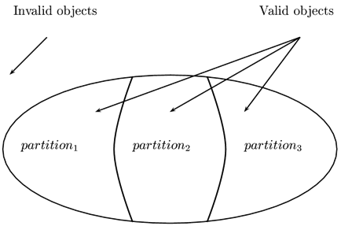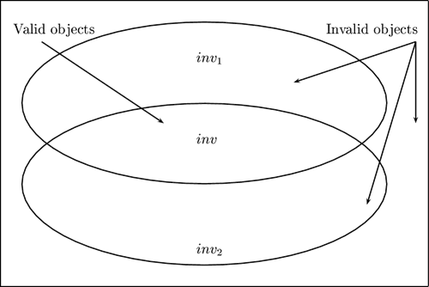

Equivalence Classes

Partitions

What I think these are?

Equivalence class is the “rule” that breaks up a set e.g. [x] = { y | y − x = 2k for some k ∈ Z

The partitions would then be the container. //Double check this, watch video

# Binary relations (Also called Vectors, see Unit 8)

* Not difficult at all. Instead of ordered pairs we could have ordered triplets or ordered quadruplets. It goes all the way up until the $n^{th}$ degree.
* Depends on the application of the data

# Functional relations

* A function f from A to B is a binary relation with *domain A* and *codomain* B, with the property that for every x ∈ A, there is exactly one element y ∈ B such that (x, y) ∈ f. (f is *functional*.)

*Function = No repeating x-values*

*Also not a difficult section. Literally look for ordered pairs where the first value is not repeated. On paper use a mapping diagram to make it a whole lot easier*

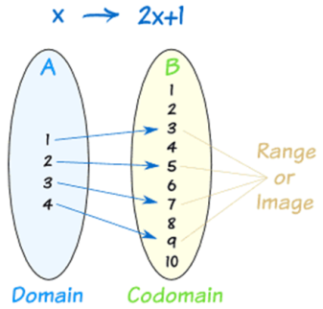

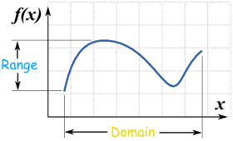

Mapping diagram

The most difficult part is just trying to find the domain. Sounds easy but for AxA Cartesian products it can get difficult. Do this ALWAYS. Even for questions that ask you for whether or not a formula/equation is a function

Example (Activity 6.14, number 3)

*Give 3 functions from A × A to B if A = {a, b} and B = {5, 6, 7}.*

AxA = {(a,b),(b,a),(a,a),(b,b) }

*You basically write out the function with these as your “x values”*